|  |  |
| --- | --- |
|  | OIL AND GAS EXPLORATION AND PRODUCTION – PHASE 3  Andrew McCown, Jeron Russell, Mark Senay,  Nico Krachenfels, Sierra Birade  **Blue Team - 3**  March 04, 2021 |
|  |  |
|  |  |

**Table of Contents**

**OVERVIEW** **2**

**Recommendations** **2**

**Methodology & Analysis** **3**

**Phase 1 Recap** **3**

**Phase 2 Recap** **3**

**Data Used** **4**

**Project NPV Simulation** **4**

**VaR & Estimated Shortfall** **6**

**Proportion of Wet Wells** **6**

**Results & Recommendations** **6**

**Conclusion** **7**

**Works Cited** **8**

**Table of Figures**

**Figure 1: Total Project Net Present Value and Value at Risk Distribution 2**

**Figure 2: Wet well NPV distribution** **3**

**Figure 3: Dry well cost distribution** **3**

**Figure 4: Histogram of the Probability of Hydrocarbons 5**

**Figure 5: Histogram of the Probability of Reservoir 5**

**Figure 6: Histogram of the proportion of wet wells 6**

**Table of Tables**

**Table 1: Data sources for the simulations 4**

**Table 2: Distribution of Risk Factors 5**

**Table 3: Final Project Potential Outcomes 7**

OIL AND GAS EXPLORATION AND PRODUCTION – PHASE 3

# **OVERVIEW**

After evaluating the potential profits and risks of venturing into the oil business and analyzing the risk associated with drilling, Compagnie Pétrolière et Gazière, INC. (hereafter the "Company") has tasked our team with making a recommendation on whether the Company should invest in the scenario. The first step is to assess the risk of drilling dry holes. Using probabilities of hydrocarbon factors associated with finding wet-wells, our team created a Monte Carlo simulation to assess possible wet-wells proportions to all wells in a distribution. Using this distribution coupled with the NPV and Cost data from Phase 2, we simulated a final NPV distribution. The median NPV for this simulation is $264,766,526. This distribution also allowed us to calculate the VaR and analyze the amount of money at risk for this scenario.

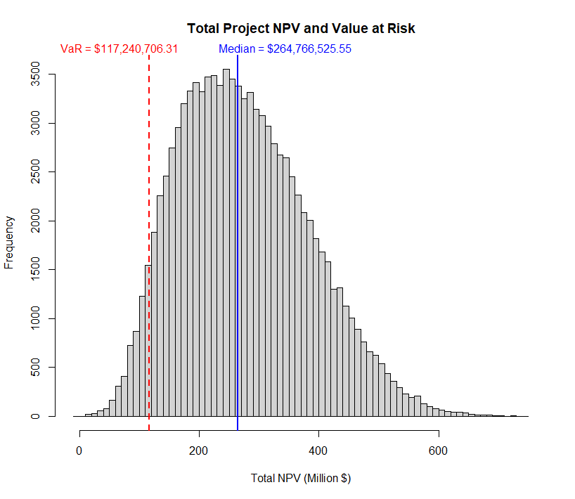

**Figure 1: Total Project Net Present Value and Value at Risk Distribution**

## Both the total NPV and VaR are displayed in Figure 1 above. The 5% VaR for this simulated scenario is $117,240,706, and the 5% estimated shortfall (CVaR) is $93,402,439. The VaR Indicates that in the bottom 5% of worst possible cases, the investment will still return an NPV of $117,240,706, and the Median indicates that in the majority of cases, the investment will return $264,766,526.

## Recommendations

* Given our findings, we see this oil venture as a relatively low-risk investment that will most likely provide a positive net return. Even in the bottom 5% riskiest situation, the average NPV should be close to $93.4M. Therefore, we recommend accepting the project.
* Even though our recommendation is to accept this project, we recommend that the Company use our analysis and figures to compare against other potential projects to ensure this venture will provide the best overall return.
* Our final recommendation is to reevaluate the investment by including environmental externalities as a cost to the project. These costs could come in various forms, such as public relations, political regulation, or environmental remediation fees.

# **Methodology & Analysis**

## Phase 1 Recap

In phase 1 of the analysis, we calculated the distribution of the arithmetic annual change on drilling costs for crude oil, natural gas, and dry wells. This distribution allowed us to get a clearer picture of the probability that specific drilling costs would occur. This enabled us to get a baseline of distribution of what it would cost to drill a well.

## Phase 2 Recap

In phase 2 of the analysis, the team focused on calculating the possible financial risks and outcomes for drilling a single dry or well. Major simulated inputs included: year 0 expenses, production risk, revenue risk, operating expenses, taxes, and net revenue interest. Combining these inputs and bringing 15-year valuations for wet wells to present value provided the following distributions. 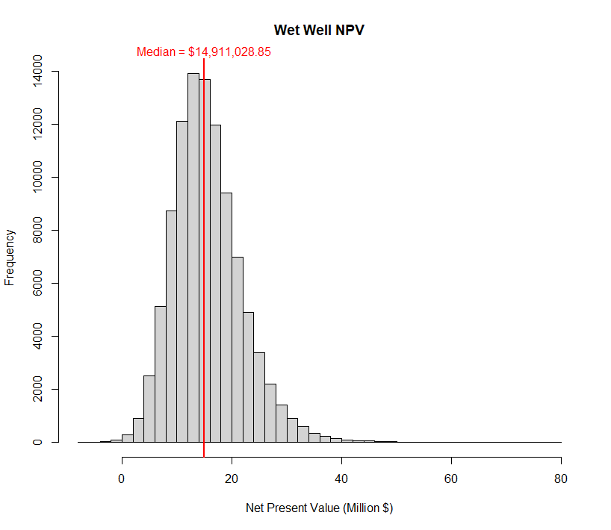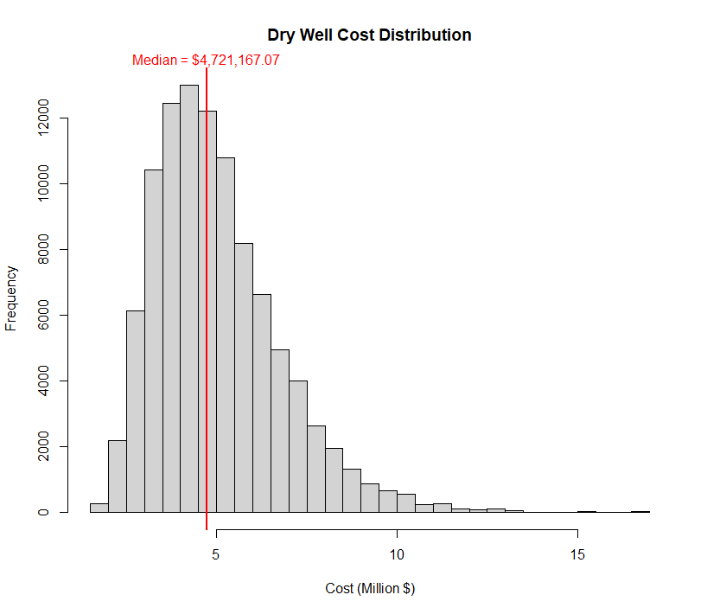

Figures 2 and 3 show the simulated outcomes for drilling and hitting an individual wet or dry well. Based on this information, it is clear that the benefit of striking a wet well outweighs the risk of hitting a dry one, holding probabilities equal. It was recommended that the proportion or likelihood of striking a wet well to a dry well be considered to assess the drilling risk further.

## Data Used

To calculate the NPV distribution and determine the measures of risk for the Company, we utilized the cumulative data, both provided and created, from phases 1 and 2 of the project. This cumulative data includes the estimated drilling costs for crude oil, natural gas, and dry wells dataset from Phase 1. The cost data used ranges from 1990-2006 and includes the annual arithmetic change on the costs mentioned above. Our cumulative data also included the estimated costs and NPV distributions that were simulated during Phase 2. A detailed data dictionary is listed in Table 1.

**Table 1: Data sources for the simulations**

|  |
| --- |
| **Data** |
| Estimated Net Present Value distribution |
| Estimated cost of hitting a dry well distribution |
| Projected NRI Interest Rate distributions over next 15 years |
| Projected overhead cost distribution over next 15 years |
| Projected oil price distribution over next 15 years |
| Projected oil production over next 15 years |
| Projected wages over the next 15 years |
| Distribution of year 0's NPV |
| Denominator for every WACC calculation over the next 15 years |

## Project NPV Simulation

The team used Monte Carlo simulations to attain a distribution of possible outcomes for the entirety of a project. To do this, the team first simulated the number of wells that were drilled and then associated each well with a probability of being wet. The team simulated the number of wells for an individual project using the specified uniform distribution of 10 to 30 planned wells provided in the RFP. To simulate the probability of a well being wet, the team used four factors:

1. Probability of Hydrocarbons
2. Probability of a reservoir being developed to hold hydrocarbons
3. Probability of an impermeable seal being available to trap hydrocarbons
4. Probability of a structure being present to cause the hydrocarbons to pool

The FRP specifies that the probability of "Structure" and the probability of "Seal" did not have any risk associated with them. Therefore, for this simulation, the probability of a wet well was calculated as,

*PWET = PHYDROCARBONS x PRESERVOIR*

The probabilities of hydrocarbons and reservoir were known to follow the truncated normal distributions in Table 2.

**Table 2: Distribution of Risk Factors**

|  |  |  |  |  |
| --- | --- | --- | --- | --- |
| **Risk Factor** | **Mean** | **Standard Deviation** | **Minimum** | **Maximum** |
| Hydrocarbons | 99% | 5% | 0% | 100% |
| Reservoir | 80% | 10% | 0% | 100% |

The team simulated the truncated normal simulations to be used in the overall simulation. The truncated distributions for hydrocarbons are shown in Figure 4, and the truncated distribution for reservoir is shown in Figure 5.

|  |  |
| --- | --- |
| **Figure 4: Histogram of the Probability of Hydrocarbons** | **Figure 5: Histogram of the Probability of Reservoir** |

Using these distributions, the team could now simulate the probability of a well being wet. After calculating the probability of a well being wet, the probability was used in a Bernoulli distribution to determine if the well was wet (1) or dry (0). By combining the results from the uniform distribution used to determine the number of planned wells and the Bernoulli distribution used to determine if those wells were wet or dry, the team could simulate how many wells were wet and how many were dry for a project. Using the simulation process for creating the loss associated with a dry well created in Phase 2, the team could simulate the cost of a dry well by pulling from the distributions that made up the loss. For the NPV of wet wells, certain components needed to stay constant across wells but vary by year, such as oil price and operating costs. We could not simply pull directly from the NPV distribution for a single wet well created in Phase 2. The team recalculated the NPV for wet wells by using the same process outlined in Phase 2 but now accounting for the factors that should remain constant across wells for each run of the simulation. Finally, the team totaled the NPV of the wet wells and subtracted the cost from the dry wells to get a final NPV for a potential project.

## VaR & Estimated Shortfall

The team used value at risk (VaR) and estimated shortfall (ES) to estimate the risk of worst-case scenarios if the Company were to go forward with a drilling project. VaR and ES were calculated for both the probability of a well being wet and for the overall expected NPV of taking on the project. By calculating a 5% VaR and ES for both the probability of a well being wet and the overall NPV, we can give the company an idea of what the worst 5% of outcomes might look like if the projects are taken on.

### Proportion of Wet Wells

Figure 6 shows the proportion of wells that were wet for the entire simulation. The 5% VaR is represented by the red dashed line and has a value of 0.59. This line depicts that 95% of the time, we expect the wet wells to make up more than 59% of the total wells drilled for a project. Furthermore, the 5% ES for the wells is expected to be 0.53. This ES indicates that given that the proportion of wet wells is below 0.59, we would expect wet wells to make up 53% of the total wells drilled for a project. Wet wells are much more profitable than the associated cost of dry wells, so seeing that wet wells are still expected to make up more than half of the total wells drilled in the worst 5% of cases, we can be optimistic about the profitability of a project.

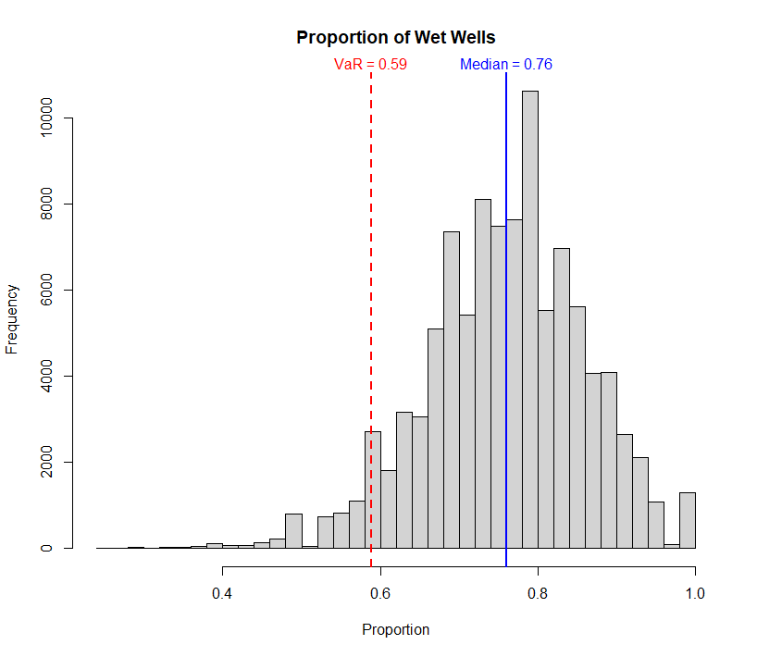

**Figure 6: Histogram of the proportion of wet wells**

# **Results & Recommendations**

We used the resulting NPVs and proportions of wet wells to simulate potential total returns from the project. Table 3 shows several potential outcomes for the project. After accounting for all possible costs and revenues, the project's median projected profit is $264.8M. We also calculated metrics to describe the possible worst and best-case scenarios. In terms of worst-case scenarios, we expect the project to return at least $117.2M with 95% confidence. Among the worst 5% of possible outcomes, the projected average return is still $93.4M. On the other hand, the projected average return among the top 5% of possible outcomes was $518.4M**.** If the Company is set on pursuing this project, we strongly believe it will be a profitable venture.

**Table 3: Final Project Potential Outcomes**

|  |  |
| --- | --- |
| **Metric** | **Result** |
| Average of bottom 5% of outcomes | $93.4M profit |
| Bottom 5th percentile of outcomes | $117.2M profit |
| Median outcome | $264.8M profit |
| Top 5th percentile of outcomes | $468.4M profit |
| Average of top 5% of outcomes | $518.4M profit |

While this oil and gas project has a high likelihood of profitability, it will require at least 15 years of oil production and a large initial investment to achieve the returns outlined above. For this reason, it could be beneficial for the company to explore the potential returns of a few other investment opportunities before committing to such an expansive project. If the oil and gas project ultimately proves to be the most lucrative option, the Company should move forward.

It is important to note that our recommendations are solely profit-based and do not consider any of the environmental externalities associated with the project. Based on estimates from the Environmental Protection Agency and the Environmental Defense Fund, the production of 1 barrel of oil results in nearly $21.50 in environmental costs. This metric is calculated using rates of 0.43 tons of carbon pollution per barrel and $50 of social cost per ton of carbon (Cassady, 2015; EDF, 2020). Given the ever-increasing awareness around environmental issues and the lengthy lifespan of this project, it is possible that the regulatory landscape changes over time and creates additional costs or regulations that affect the project's profitability.

# **Conclusion**

We conducted various simulations to calculate the potential costs and revenues associated with an oil and gas venture. In this case, the project is expected to be profitable in the majority of scenarios, with a median projected profit of $264.8M and a 5% value at risk of $117.2M. Although this project is expected to be profitable, there are other factors that the Company should consider, such as the associated environmental costs and whether other investments over the 15-year time period could be more lucrative than the oil and gas venture. We have enjoyed working on this project and would be happy to conduct additional simulation and risk assessments on behalf of the Company in the future.

# 

# 

# **Works Cited**

Cassady, Matt Lee-Ashley and Alison. "The Environmental Impacts of Exporting More American Crude Oil." *Center for American Progress*, 20 Aug. 2015, www.americanprogress.org/issues/green/news/2015/08/21/119756/the-environmental-impacts-of-exporting-more-american-crude-oil/.

"The True Cost of Carbon Pollution." *Environmental Defense Fund*, 22 July 2020, www.edf.org/true-cost-carbon-pollution#:~:text=The current central estimate of,economic impacts of climate change.